Lab Number 1 Report

Ben Simpson, Section # 001

Benjamin Bergeson, Section # 001

**Introduction**

This lab is intended for us to learn the following principles: (1) Using LT Spice simulation to predict circuit performance, (2) Constructing a breadboard circuit, (3) Characterizing and debugging a circuit, and (4) Designing frequency filtering circuits.

**Lab Work**

1. **DC Analysis**

Figure 1 shows the DC circuit that we simulated in LTSpice.

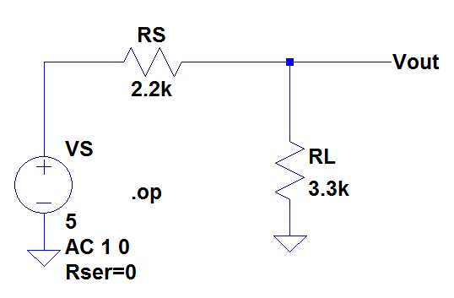

Figure 1. Simple Voltage Divider Circuit

Table 1 shows the currents and voltages across elements in the DC circuit.

Table 1

|  |  |
| --- | --- |
| Voltage across RL | 3 V |
| Voltage across RS | 2 V |
| Current through all Elements | 0.000909091 Amps |

We calculated the Thevenin resistance of the circuit in figure by adding a 1k ohm resistor in parallel with RL and using the following equation.



Vth was found to be 3 V using the LTSpice simulation from Table 1. We repeated the simulation after adding the 1k ohm resistor and found V to be 1.2931 V. Using this we solved the above equation and found RTh to be 1320 Ohm.

1. **AC Analysis**

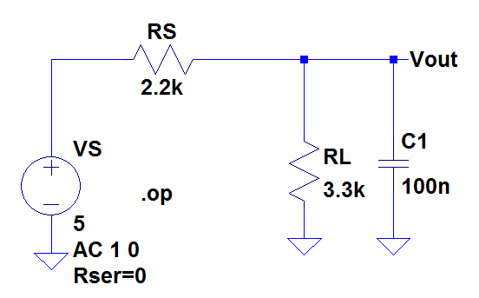

Figure 2. Frequency Dependent Circuit

Using the Thevenin equivalent circuit that we calculated in the DC Analysis, we created a simplified version of the circuit in Figure 2. (The simplified circuit is shown in Figure 3.)

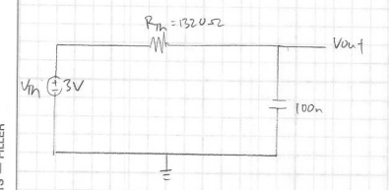

Figure 3. Thevenin Equivalent of Figure 2

Using this, we determined that the circuit in Figure 2 is a low pass filter. A frequency response plot showing the corner frequency and Bode approximation shown in Figure 4.

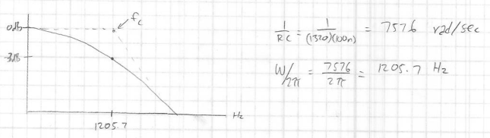

Figure 4. Bode plot and calculations for Figure 3

Next, we built the circuit from Figure 2 and verified our calculated corner frequency. We found that the corner frequency of the actual circuit was 1350 Hz compared to our calculated frequency of 1205 Hz. Our oscilloscope measurements are shown in Figure 5.

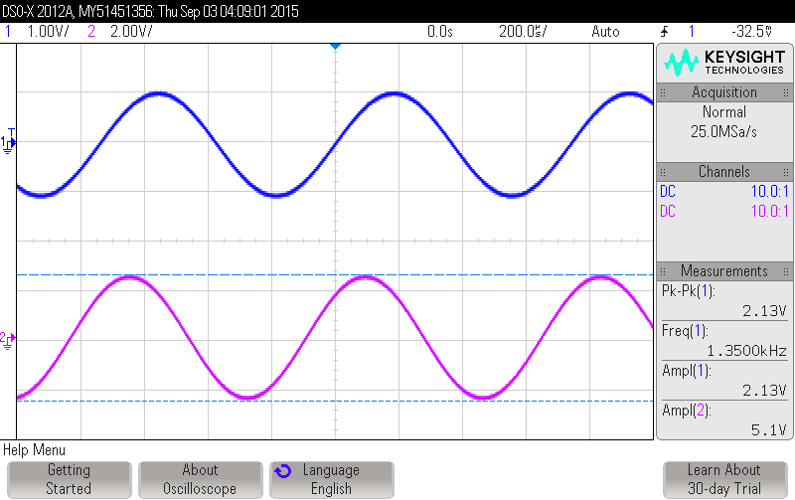

Figure 5. Oscilloscope screen capture

1. **Summary**

This lab was a great refresher on how to use the waveform generator, the oscilloscope, and LT Spice. We were able to design a circuit in LT Spice to evaluate its performance and simulate the outputs to ascertain our calculations. We then physically built the circuit and tested it with the oscilloscope to confirm our simulations.